**Project Planning Phase**

**SPRINT DELIVERY - 2**

|  |  |
| --- | --- |
| Team ID | PNT2022TMID24776 |
| Project Name | Project – Smart Farmer-IoT based Smart Farming Application |
| Maximum Marks | 8 Marks |

**IBM Watson IoT Platform**

A fully managed, cloud-hosted service with capabilities for device registration, connectivity, control rapid visualization and data storage. IBM Watson IoT Platform is a managed, cloud-hosted service designed to make it simple to derive value from your IoT devices.

**Steps to configure:**

• Create an account in IBM cloud using your email ID

• Create IBM Watson Platform in services in your IBM cloud account

• Launch the IBM Watson IoT Platform

• Create a new device

• Give credentials like device type, device ID, Auth. Token

• Create API key and store API key and token elsewhere.

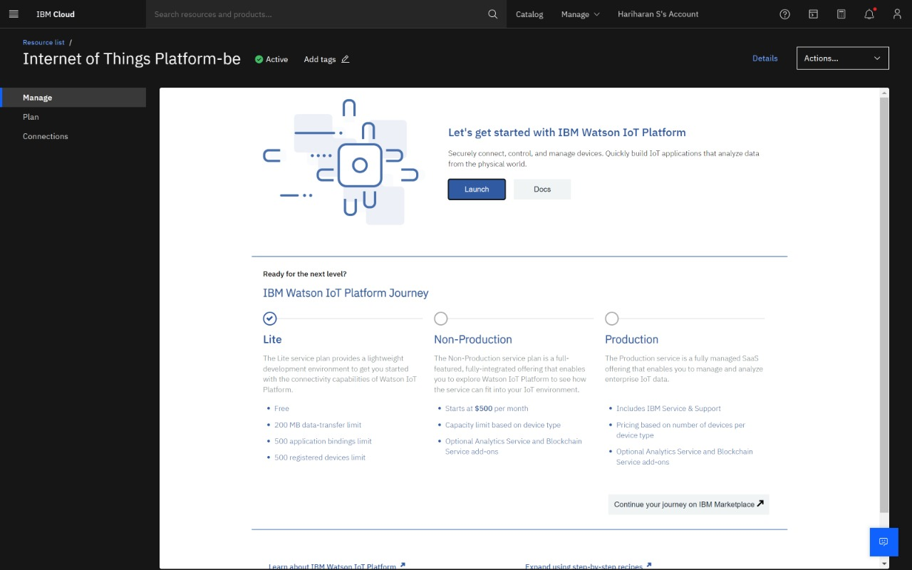

IBM Watson IoT Platform

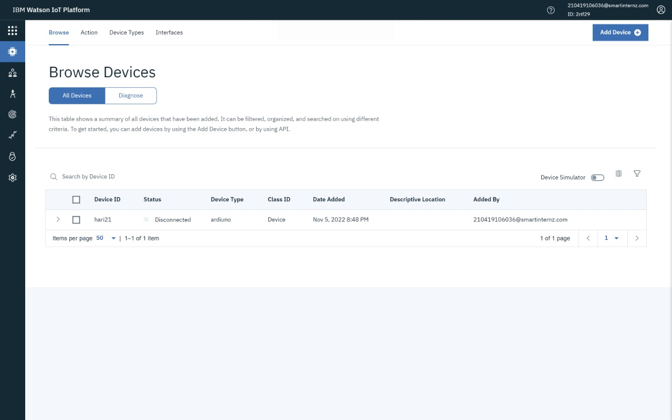

**NODE RED**

Node-RED is a flow-based development tool for visual programming developed originally by IBM for wiring together hardware devices, APIs and online services as part of the Internet of Things. Node-RED provides a web browser-based flow editor, which can be used to create JavaScript functions.

**DIAGRAM**

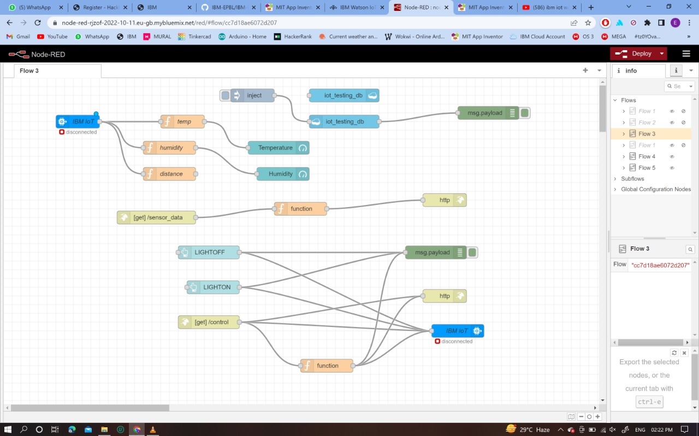

**NODE INTERFACE:**

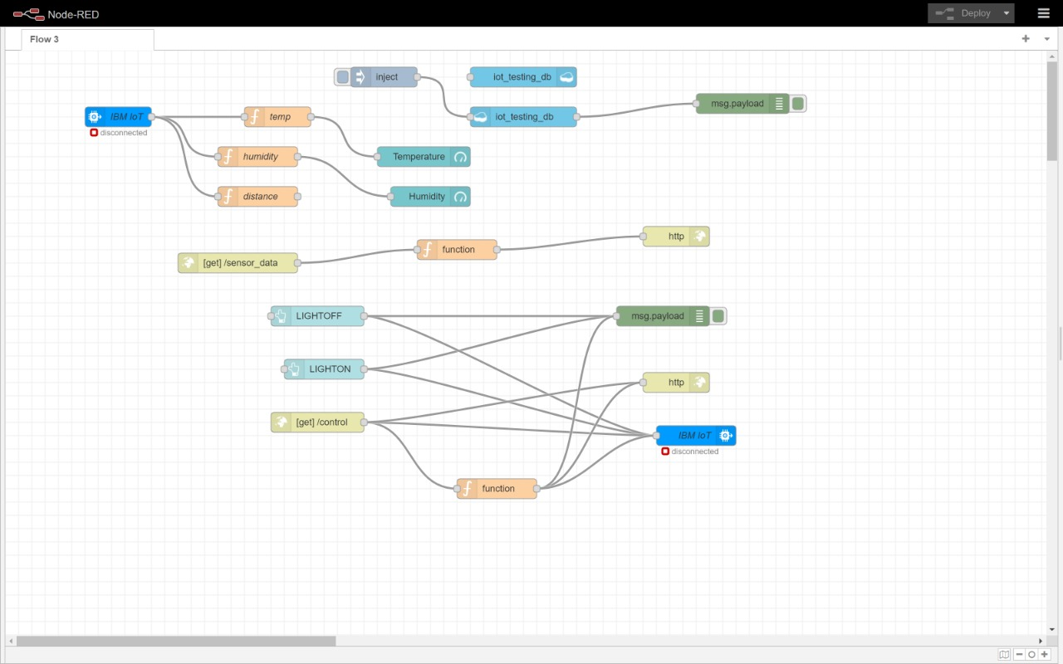

**INSTALATION**

• First install npm/node.js

• Open cmd prompt

• Type => npm install node-red

**TO RUN THE APPLICATION:**

• Open cmd prompt

• Type=>node-red

• Then open http://localhost:1880/ in browser Installation of IBM IoT and Dashboard nodes for Node-Red In order to connect to IBM Watson IoT platform and create the Web App UI these nodes are required

1. IBM IoT node

2. Dashboard node

**OPEN WEATHER API**:

Open Weather Map is an online service that provides weather data. It provides current weather data, forecasts and historical data to more than 2 million customer.

Website link: <https://openweathermap.org/guide>  
 Steps to configure:

o Create account in Open Weather

o Find the name of your city by searching

o Create API key to your account

o Replace “city name” and “your api key” with your city and API key in below red text api.openweathermap.org/data/2.5/weather?q={city name}&appid={your api key}

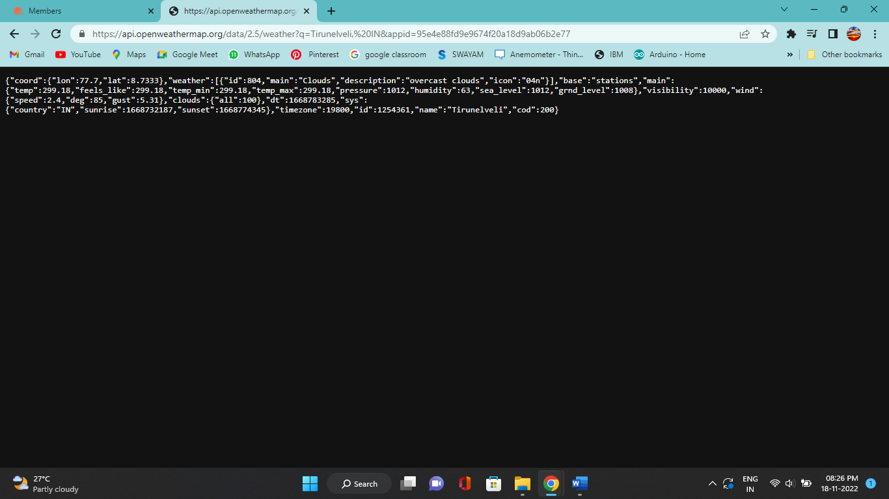

Configuration of Node-Red to collect data from Open Weather

The Node-Red also receive data from the Open Weather API by HTTP GET request. An inject trigger is added to perform HTTP request for every certain interval. HTTP request node is configured with URL we saved before in section 4.4 The data we receive from Open Weather after request is in below JSON format:

{"coord":{"lon":79.85,"lat":14.13},"weather":[{"id":803,"main":"Clouds"," description":"brokenclouds","icon":"04n"}],"base":"stations","main":{"temp":307 59,"feels_like":305.5,"temp_min":307.59,"temp_max":307.59,"pressure":1002,"h umidity":35,"sea_level":1002,"grnd_level":1000},"wind":{"speed":6.23,"deg":170} ,"clouds":{"all":68},"dt":1589991979,"sys":{"country":"IN","sunrise":1589933553, "sunset":1589979720},"timezone":19800,"id":1270791,"name":"Gūdūr","cod":20 0}

In order to parse the JSON string we use Java script functions and get each parameters

var temperature = msg.payload.main.temp;

temperature = temperature-273.15;

return {payload : temperature.toFixed(2)};

In the above Java script code we take temperature parameter into a new variable and convert it from kelvin to Celsius .

Then we add Gauge and text nodes to represent data visually in UI

